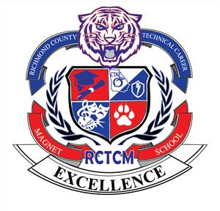

Welcome to RCTCM and to our CTAE Department!!

My name is Mrs. Holston and I will be teaching the following courses during the 2022-2023 school year:

**Foundations of Energy**

**Energy and Power**

**Energy Applications**

**Foundations of Electronics**

**Advanced AC/DC Circuits**

**Digital Electronics**

**Inventions and Innovations**

**Work-Based Learning**

My office hours will be Monday through Friday 3:00 pm – 3:50 pm with the Wednesday slot of time being dedicated to tutoring (upon request).

I can be reached by phone at 706-823-5580 and by email at holstsh@boe.richmond.k12.ga.us.

Please feel free to contact me with any questions that you may have.

I am looking forward to a wonderful White Tiger Year!!!